|  |  |  |  |
| --- | --- | --- | --- |
|  | **Bansilal Ramnath Agarwal Charitable Trust's**  **Vishwakarma Institute of Information Technology**  **Department of**  **Artificial Intelligence and Data Science** | | |
| Student Name: Siddhesh Dilip Khairnar | | | |
| Class: S.Y. | Division: B | | Roll No: 272028 |
| Semester: IV | | Academic Year: 2022 - 23 | |
| Subject Name & Code: Fundamentals of Computer Networks: ADUA22203 | | | |
| Title of Assignment: Demonstrate the different types of topologies and types of transmission media by using a packet tracer tool. | | | |
| Date of Performance: 1/02/2023 | | Date of Submission: 10/02/2023 | |

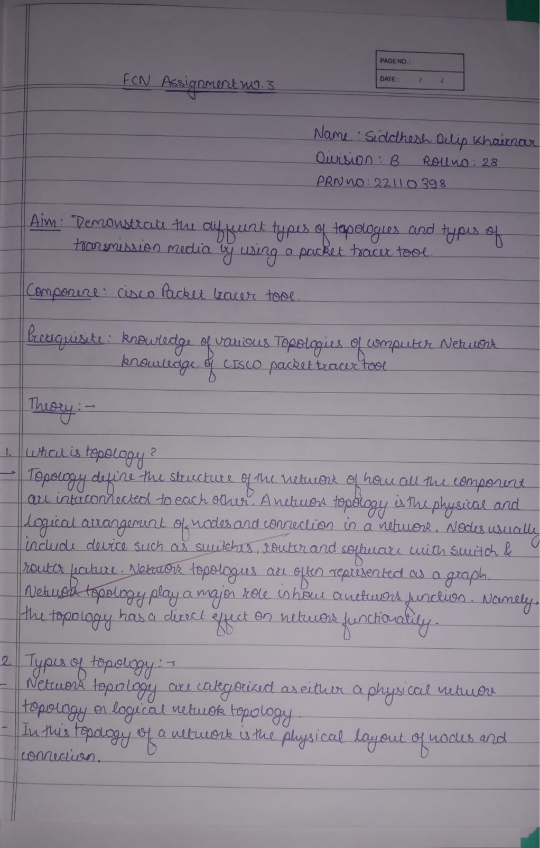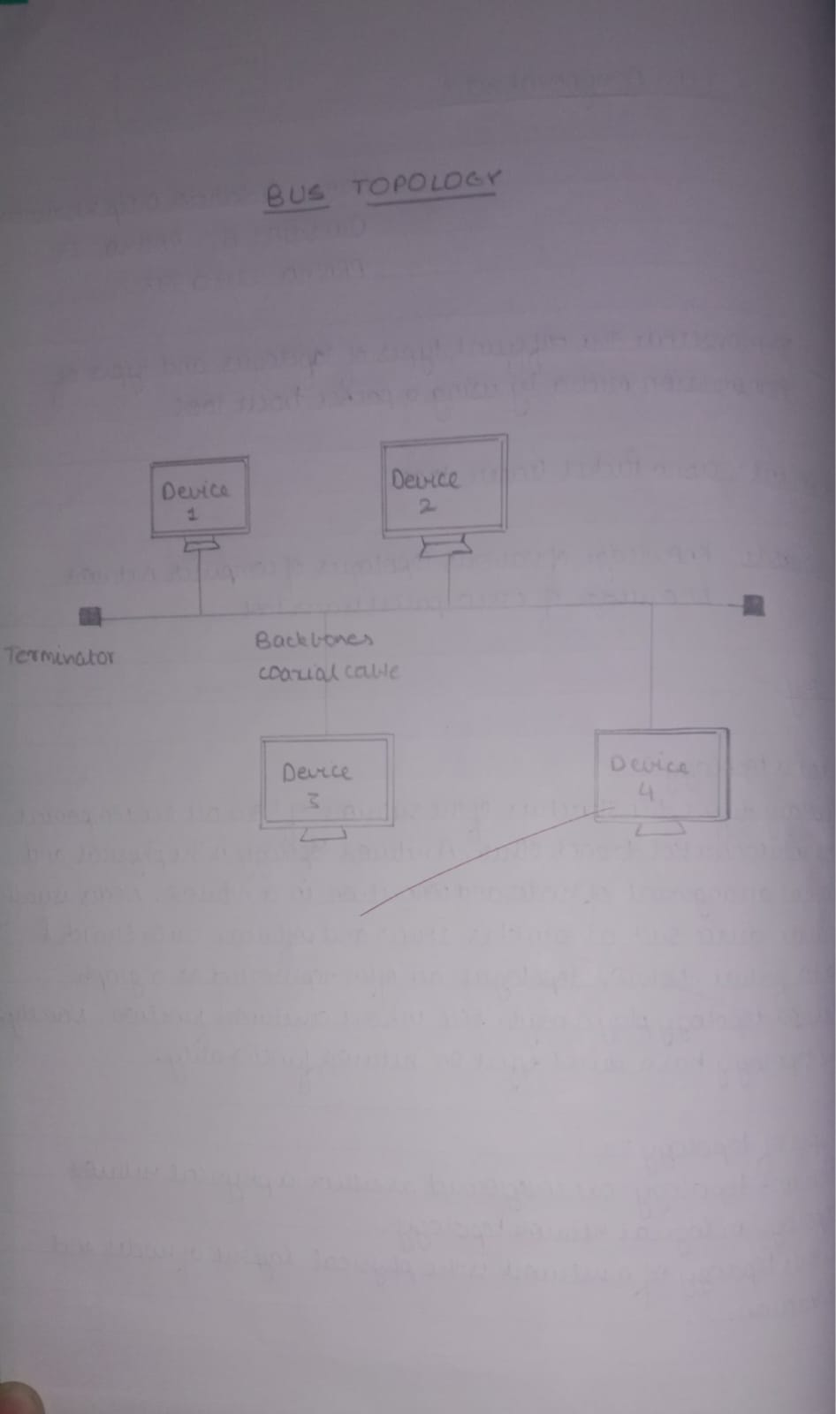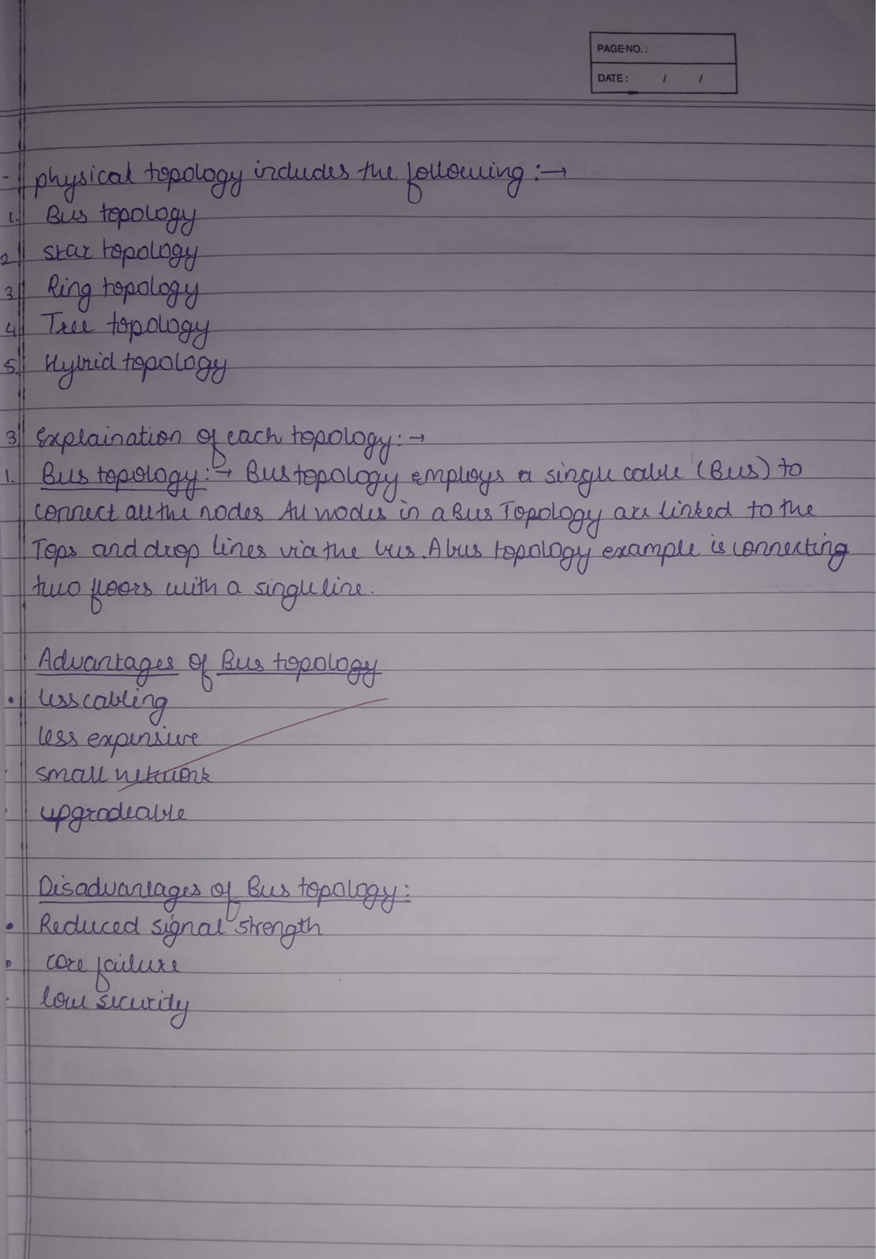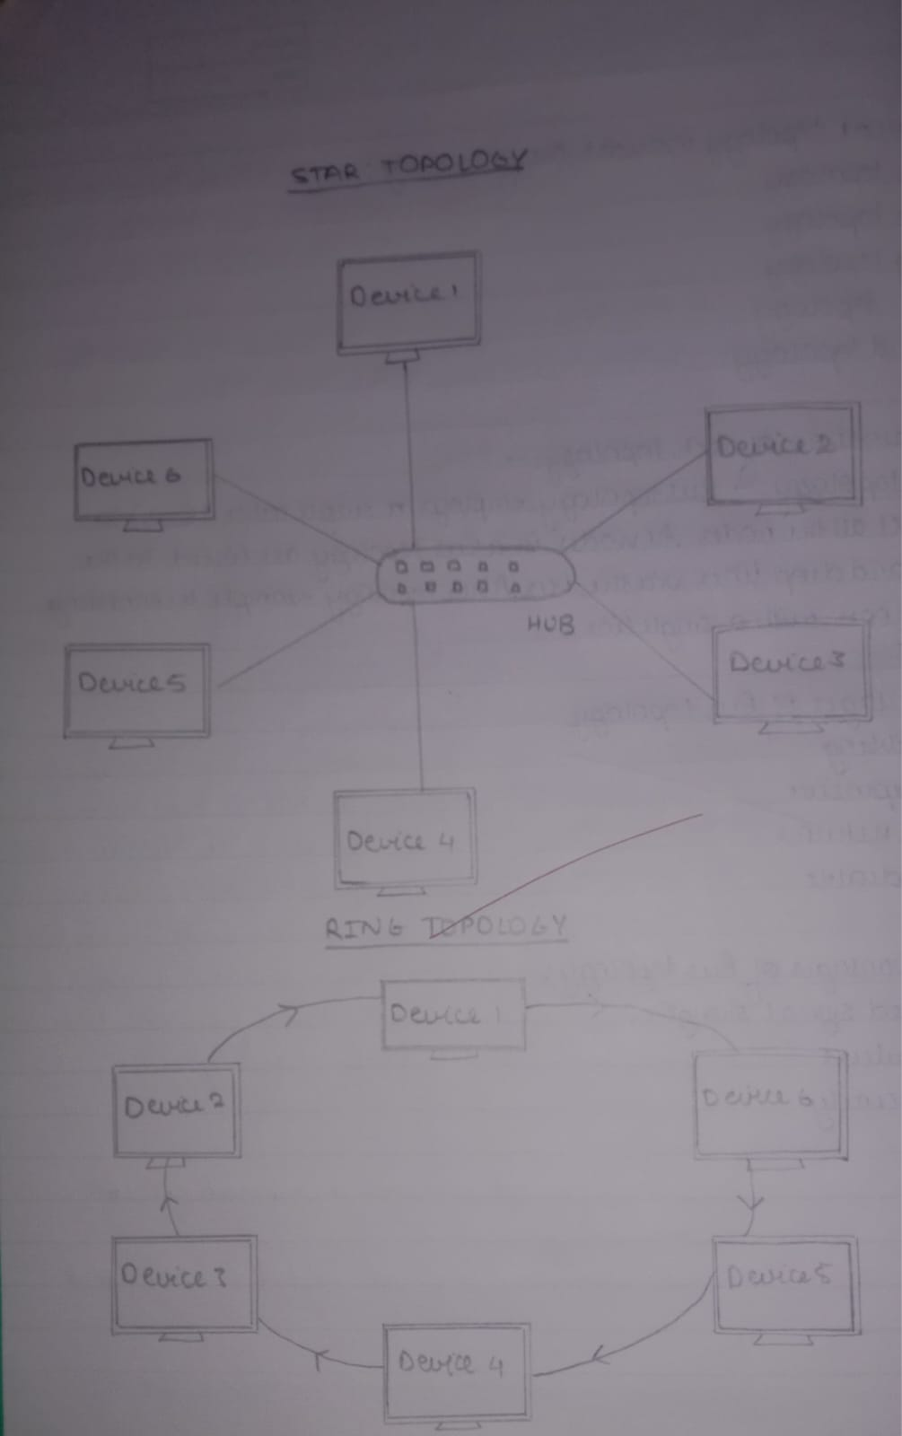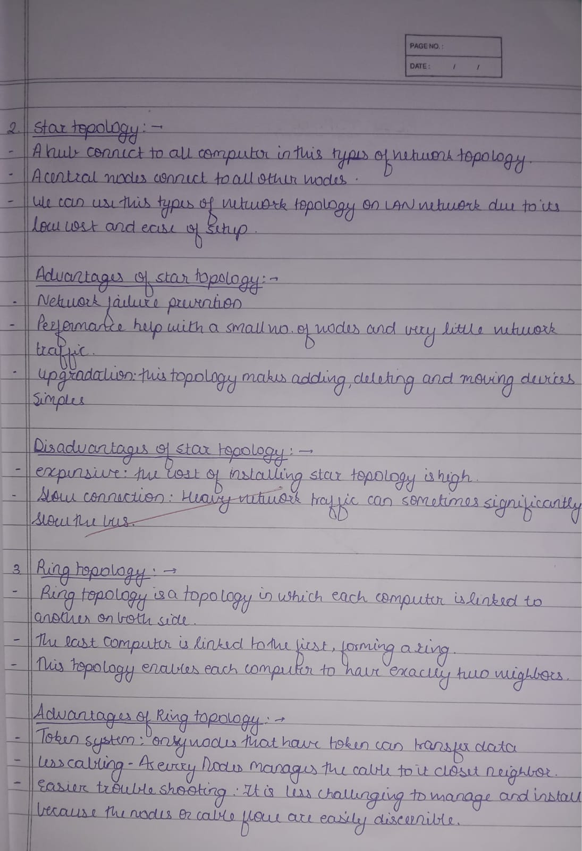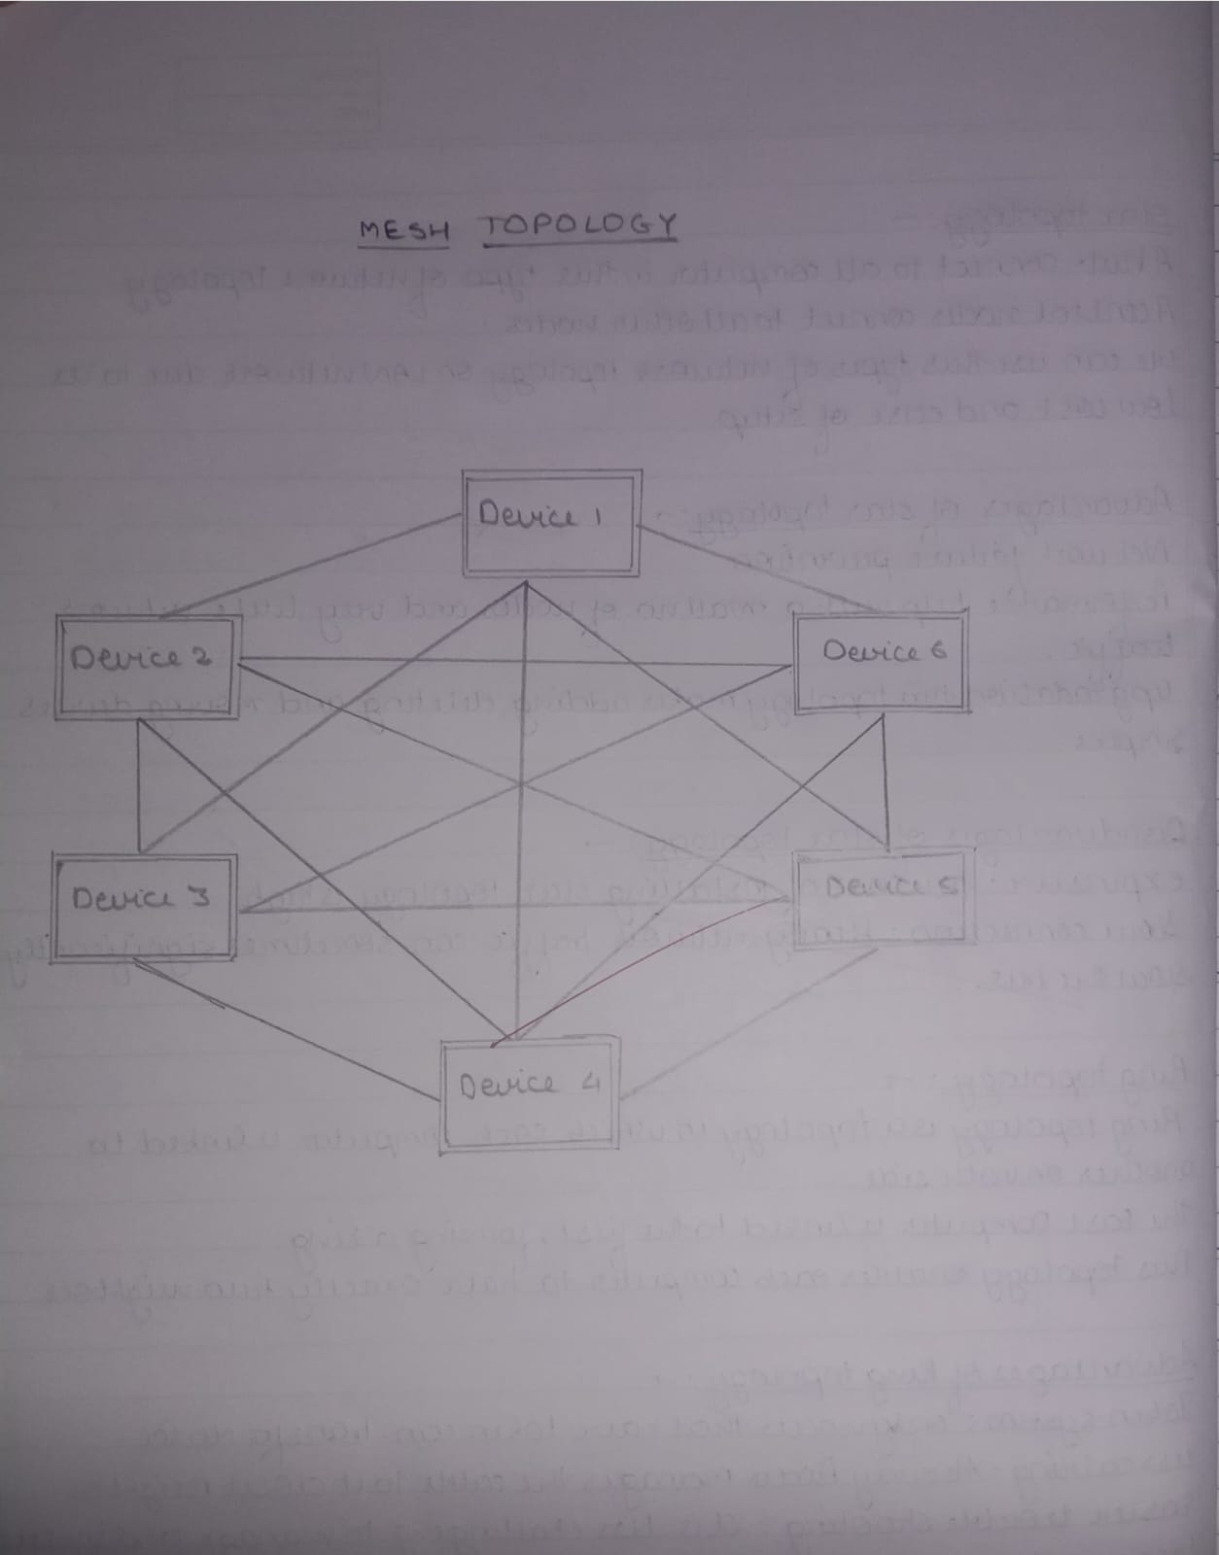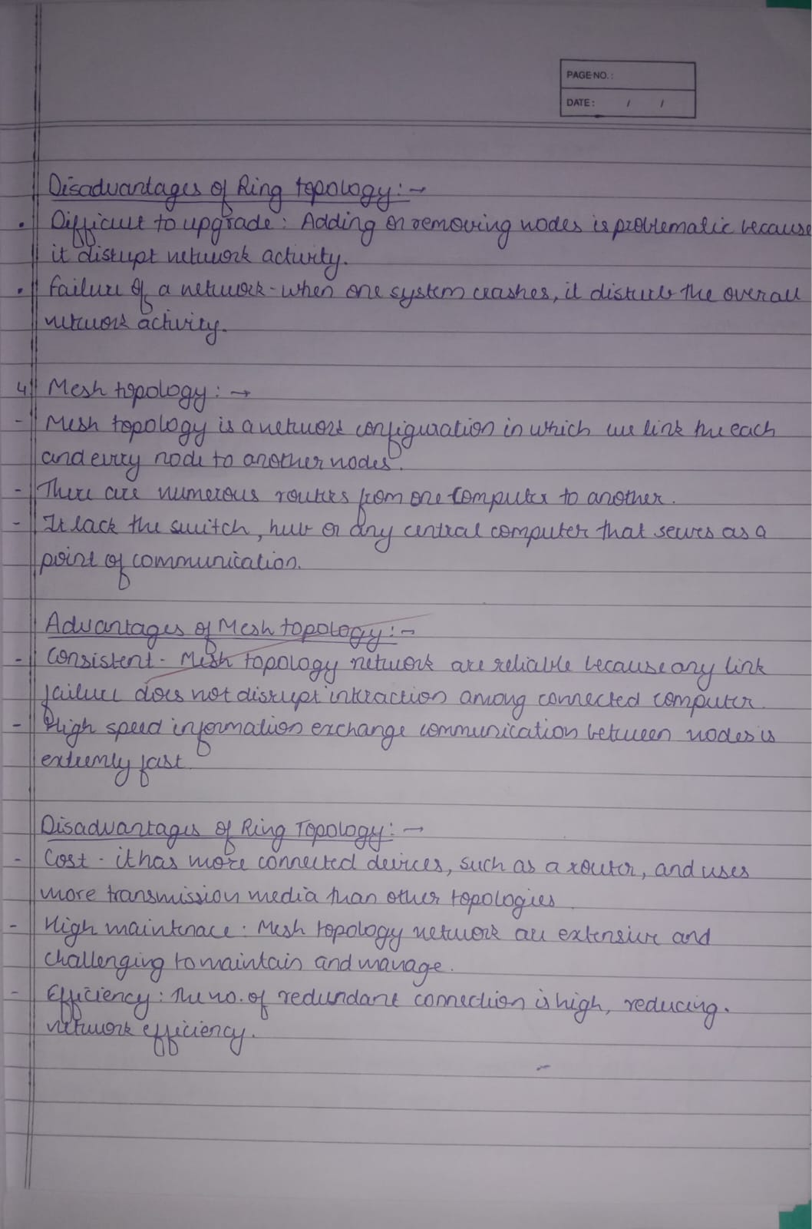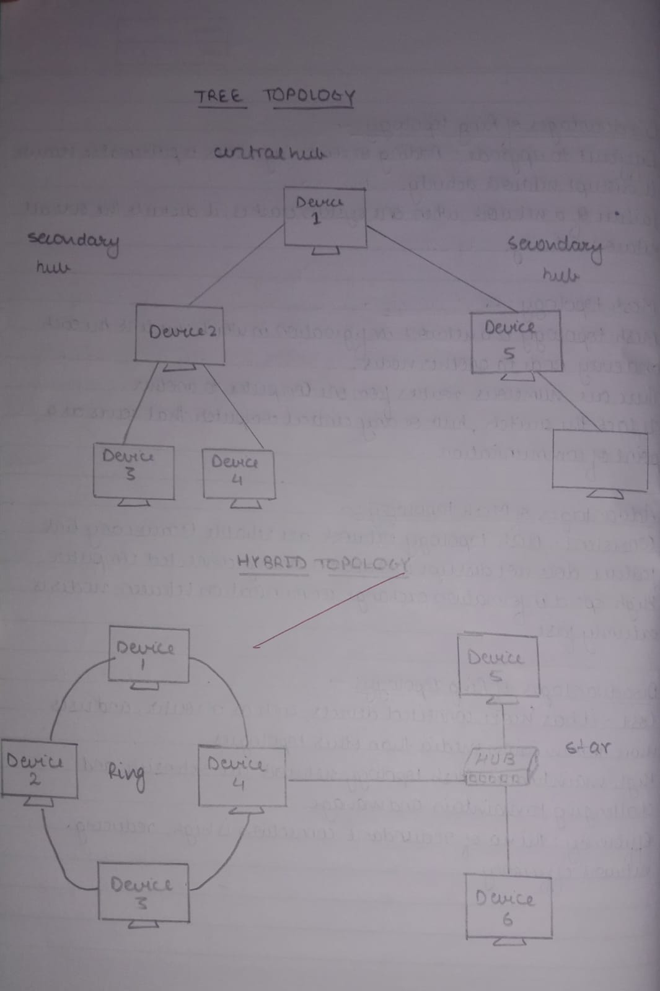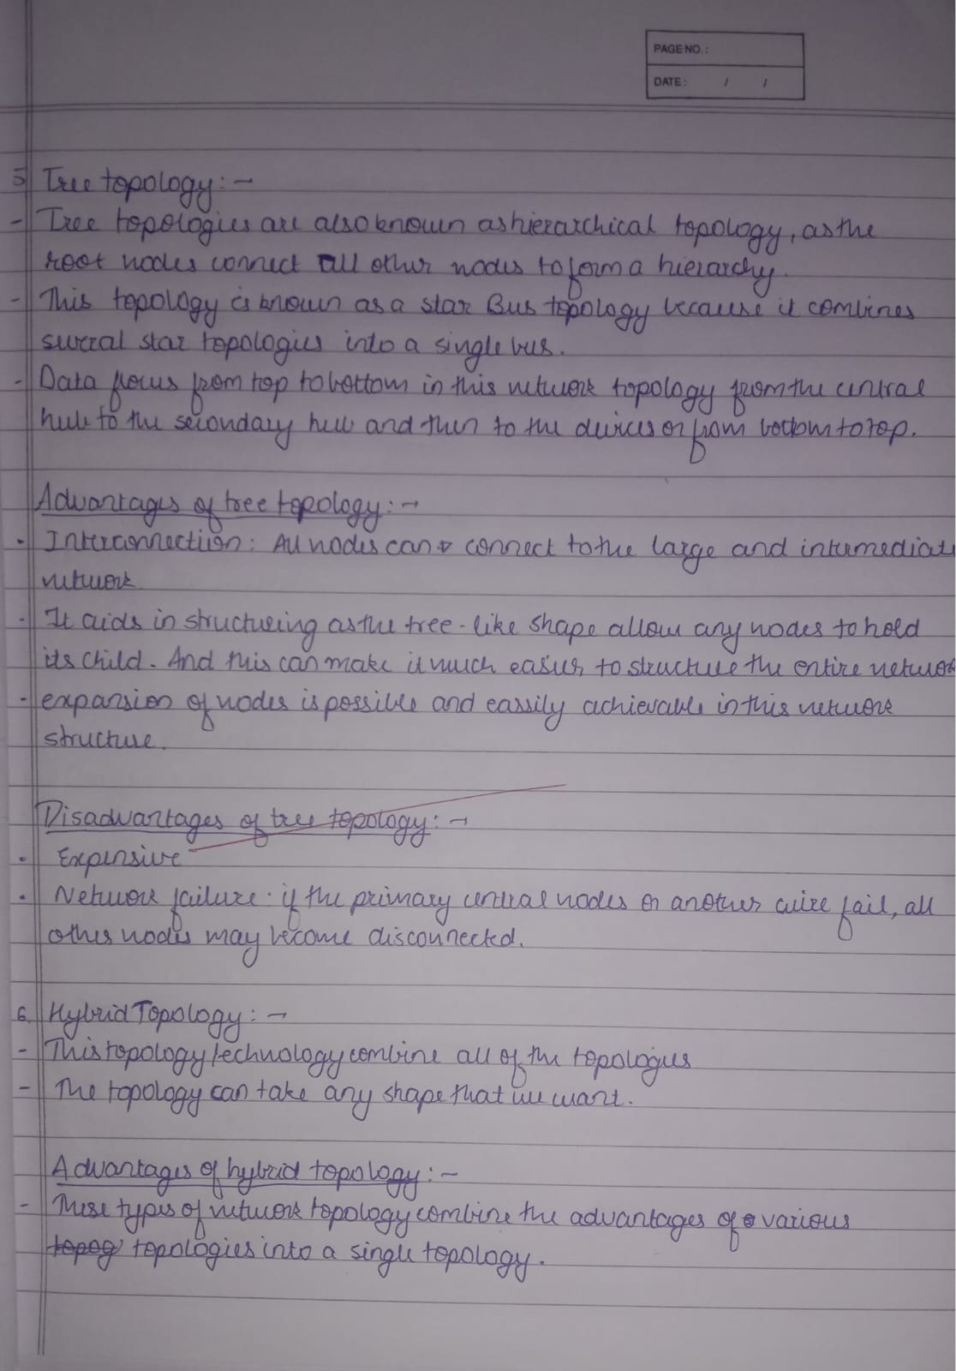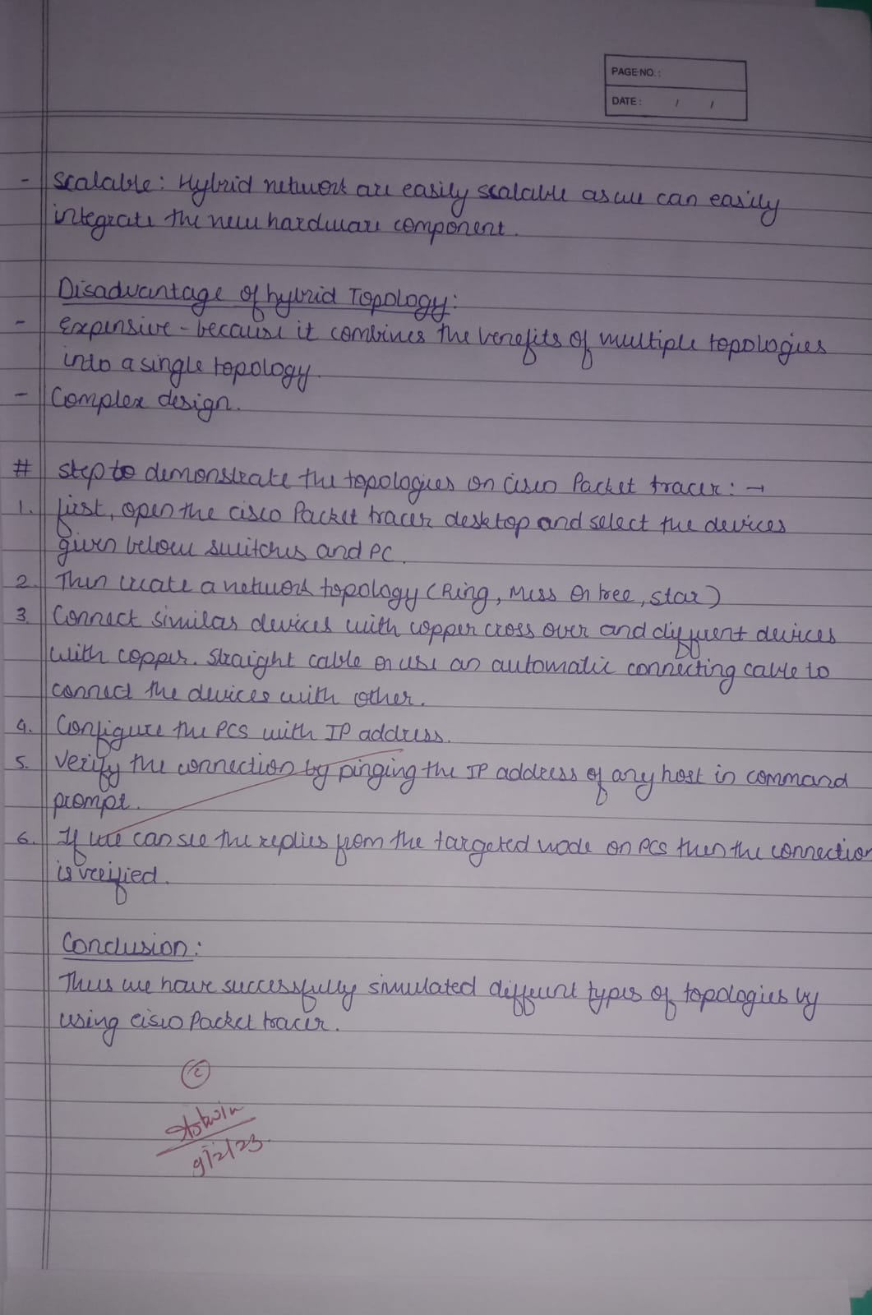

Snapshot:

